18.86: a) The partial pressure is This is close to the vapor pressure at 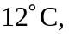 which would be at an altitude above the ground (more precise interpolation is not warranted for this estimate).
b) The vapor pressure will be the same as the water pressure at around 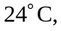 corresponding to an altitude of about 